Assignment #4

# Basic Info:

* This assignment is **graded**, worth 25 points (out of 500 points in total); late assignments are penalized 25% per day
* Deadline is 05/29/24, Wednesday, 11:59 PM.
  + If the Syllabus and/or class notification made by instructor or TAs indicates a different deadline, please refer to the latest information.

# Repository setup:

This section was previously used for the instruction for GitHub repo setup. Since we're using BruinLearn platform now, you don't need to do the setup; continue with the next step.

Of course, you should unzip the assignment material to your local file system (please unzip if you're reading this line inside the compression file preview now) and you can optionally use git to control your version.

You can continue with an IDE or using Chrome DevTools and we strongly recommend the using of the IDE (For instruction about how to use an IDE, please refer to TA sections).

If you want to debug with Chrome DevTools, you can now follow the remaining steps of the assignment. This [debugger instruction](https://docs.google.com/document/d/e/2PACX-1vSi14Mb-_6qLN7wVA4-4NxqYR-3qHLy7ndjB2G0Ba6TCYHn_KGmrPbu-fCDtHkv9QcGBNqLUUdT6fu1/pub) can be helpful when your code does not work.

# Graded Steps

According to the plagiarism policy and integrity code, you are not allowed to copy or use any codes form resources that are not covered in lecture or discussion in this quarter, including github repo’s, other students’ code, stack overflow, GenAI (i.e. ChatGPT) , etc. If you use resources mentioned in lecture or discussion in this quarter, please credit them in your codes.

Implement the assignment in clean and understandable code. Each required part must successfully draw and show up onscreen in order to count. If you use code that you found online, you must cite it inside your program file otherwise that is plagiarism.

## Point distribution

1. Implement functionality to load two different square images of your choice into texture maps. You must include whatever files are needed for us to run your code in the "assets" folder of your repository (images, etc.) - 2 points

Remember, not just any image that you download will work. Images used for texture maps in WebGL 1.0 must be square and have power of two dimensions (therefore only square images of a few limited sizes like 128x128 and 256x256 are valid). WebGL 2.0 doesn't have this limitation but it also isn't widely supported on phones yet so we don't use it.

To load a texture into a Material , assign a new value to the object called

Material

"texture" . To assign with the right value, use one of our functions that returns

"texture"

a reference to an image file. Load your image using the class Texture , found in

tiny-

graphics.js . You can read the class to see what this class does.

Texture

A Texture 's color is scaled by the Phong formula's ambient weight. Make your image match

its original colors this time, by setting the ambient to opaque black and adjusting the

color

ambient . (FYI, images with transparent pixels are accounted for in the formula too -- the shape's base color affects the texture's color additively, but the transparencies combine multiplicatively).

**Note: Please avoid using images associated with politics or political figures**

Hint: You can use the images under the

assets

assets/stars.png : 512x512

assets/earth.gif : 128x128

folder, like following files:

1. Apply the entire first texture image onto each face of a cube (cube #1) that has dimensions



s



t

2x2x2. The texture coordinates should range from (0,1) in both the

and

dimensions.

Filtering should be set to use nearest neighbor (set the second parameter for Texture constructor as "NEAREST" ). – 3 points

1. Create a second cube (cube #2) with dimension 2x2x2 where the second texture image is applied to each face but is zoomed out by 50% (the image should shrink; the whole image will appear four times, once in each corner). Enable Mip Mapping for the zoomed texture using tri-linear filtering (set the second parameter for Texture constructor as "LINEAR_MIPMAP_LINEAR" ) - 2 points
2. Position both cubes side by side within the view of your starting camera view: Place the camera 8 units back from the origin. Both cubes should have a dimension of 2x2x2. Place the center of cube #1 at (-2,0,0) and the center of cube #2 at (2,0,0). Use perspective projection. As you move the camera nearer or farther away, along the z-axis, from the cubes we should see the effect of the texture filtering as the textures get smaller or larger. For the cube that uses poor sampling, the image should show grainy, flashing static noise at the pixel level - 2 points

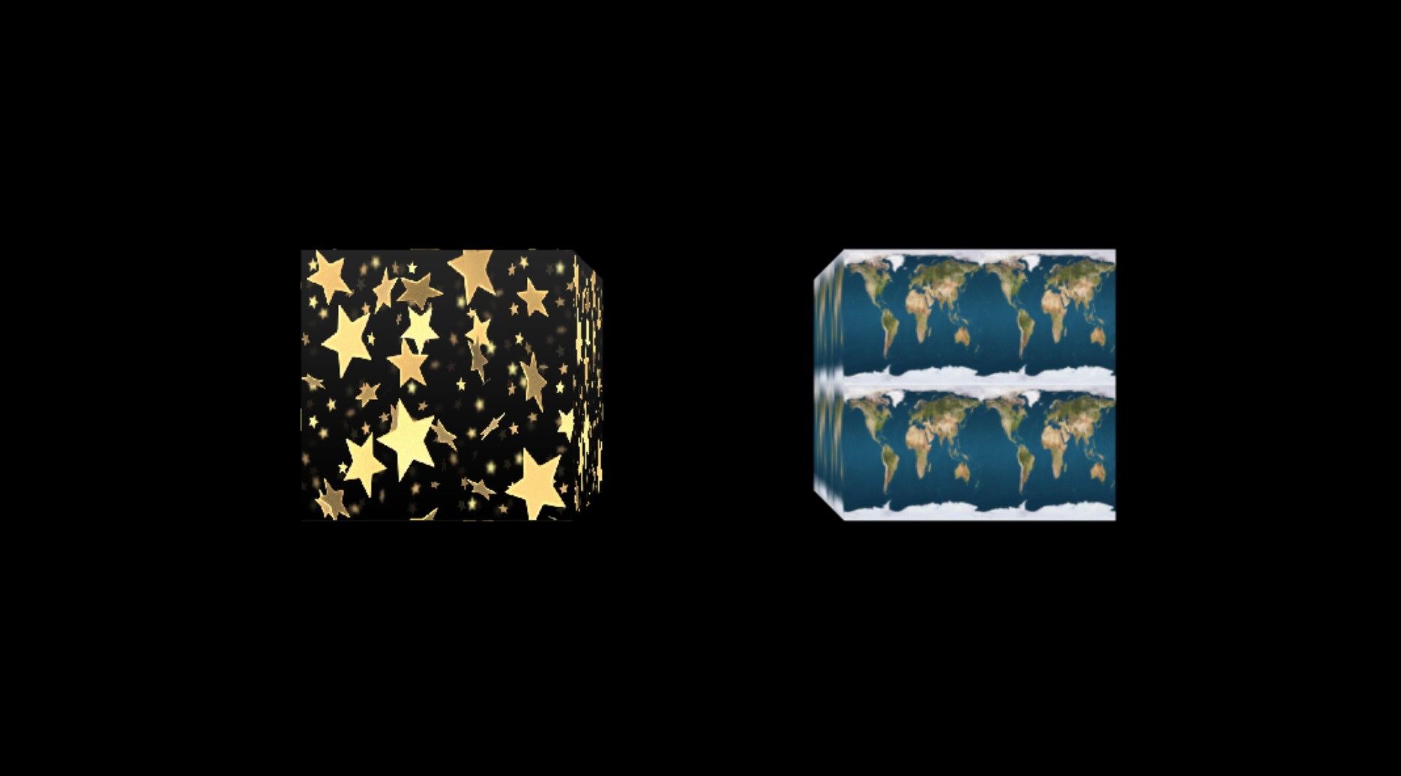

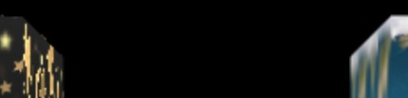Hint: if you set up the scene and texture correctly, the position of the cubes should look like the above (Of course you might choose different texture images). Note that different texture filtering method will cause difference when texture is "compressed" due to our viewing

angle, like following:

1. Use key ‘c’ (with our usual web buttons) to start and stop the rotating both cubes. Cube #1 should rotate around its own X-axis at a rate of 15 rpm. Cube #2 should rotate around its own Y-axis at a rate of 40 rpm. The cubes should not jump to a different angle when they start and stop - 4 points

(GIF)

1. Use continuous scrolling the texture map on cube #2. Translate the texture varying the s texture coordinate by 4 texture units per second, causing it to slide along the box faces.

Reset the texture coordinates passed into the GLSL's call periodically so they do

texture2D

not continue to grow forever, which could cause the interpolated values to lose needed decimal precision - 4 points

To code this part, fill in class Texture_Scroll_X which will be a modification of

shader, overwriting its fragment shader code. Use that shader instead of

Textured_Phong

fragment_glsl_code

Textured_Phong

function to give it new for cube #2.

Note 1: In the fragment shader, the varying " f_tex_coord " stores the vec2 of pre- interpolated texture coordinates.

Note 2: The variable fragment shader for you.

animation_time

is already passed all the way through into the

Warning: When coding in GLSL, integer literals like "2" cannot be used most of the time. Use floats instead by ending your number in a decimal. Also, you'll have to describe PI for it since there is no built-in constant. You can make a 4x4 matrix of any form using

the constructor, where the matrix is in *column-major* order (the first four

mat4()

entries are the first column, etc).

1. Rotate the texture map itself on all faces of cube #1 around the center of each face at a rate of 8 rpm. As with #6, prevent the rotation angle from growing excessively as

animation_time

grows - 4 points

To code this part, fill in class Texture_Rotate which will be a modification of

Textured_Phong , overwriting its shader code. Use that shader instead of

fragment_glsl_code

Textured_Phong

function to give it new fragment for cube #1.

(GIF)

1. Now add the outline of a black square in the center of each texture that moves with the texture. This should be done by just modifying the fragment shader. - 4 points

The dimensions of the black square in the texture coordinate space are shown below:

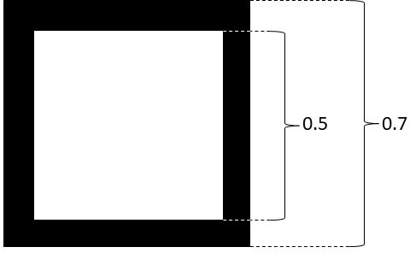

Note 1: Recall that one of the cubes has 4 instances of the texture on one face. This cube requires 4 black square outlines in the center of each texture instance.

Below is what the square outlines should look like if the textures aren't moving:

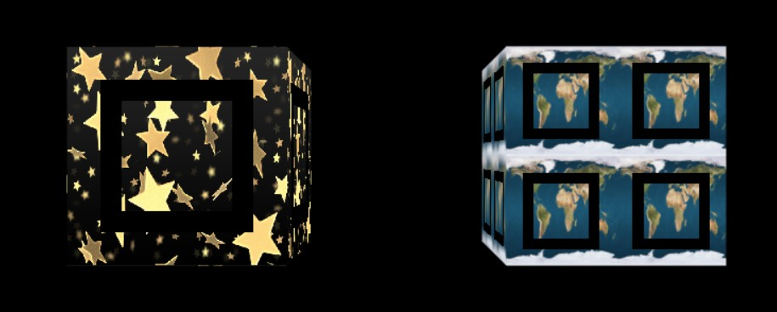

And below is what the square outlines should look like if the textures are moving:

(GIF)

# Submitting Assignment 4:

Compress (zip) the whole assignment folder into a ZIP format compressed file. Submit it to the Assignment in BruinLearn where you download this.

Please make sure you included everything in the assignment, rather than only the file(s) you made changes. The structure of the compressed file should be the same with the provided assignment material.